For Email_Pipeline Project
- Setup extended email notifications
- Goto>dashboard>Manage Jenkins>global tool configuration> scroll to Extended E-mail Notification(This Extension need to be donwloaded)
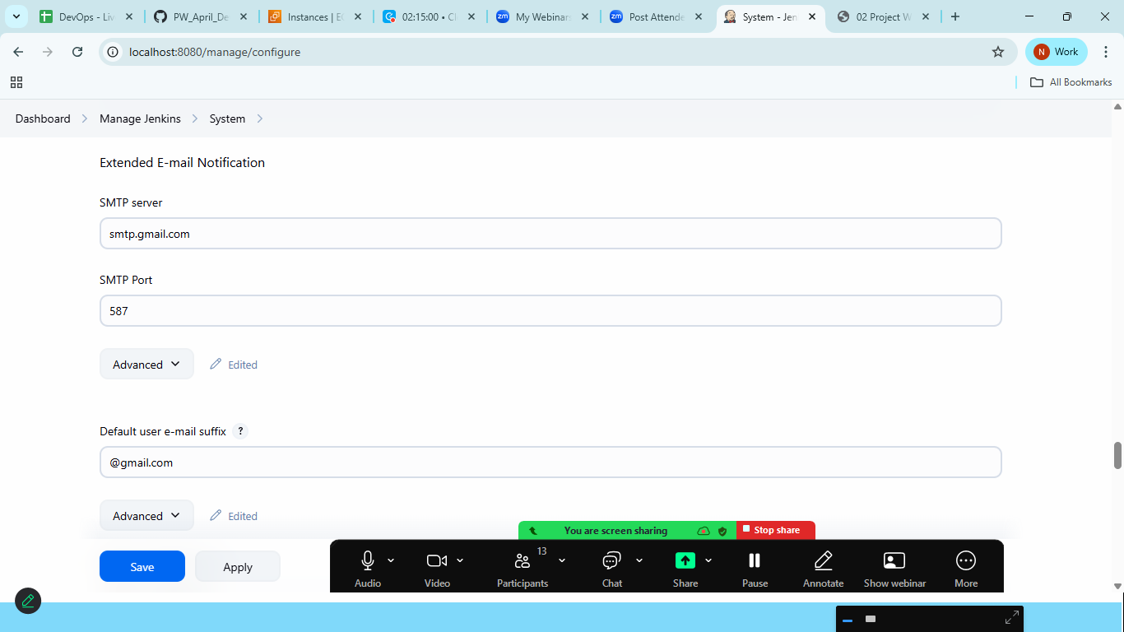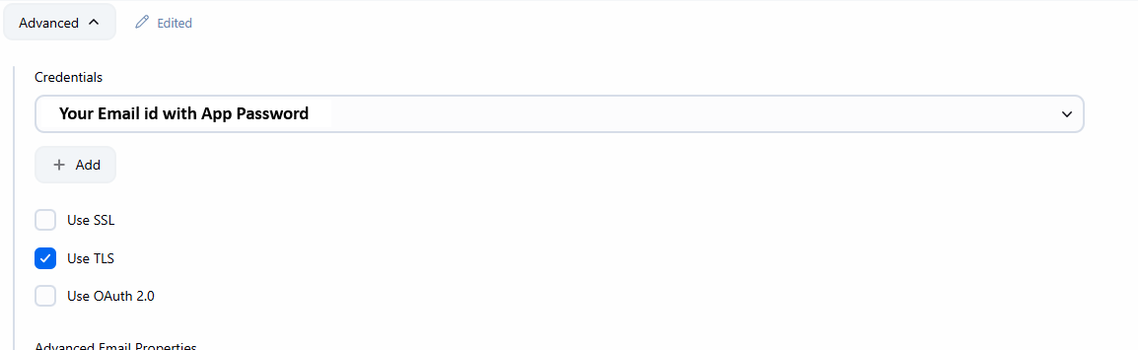
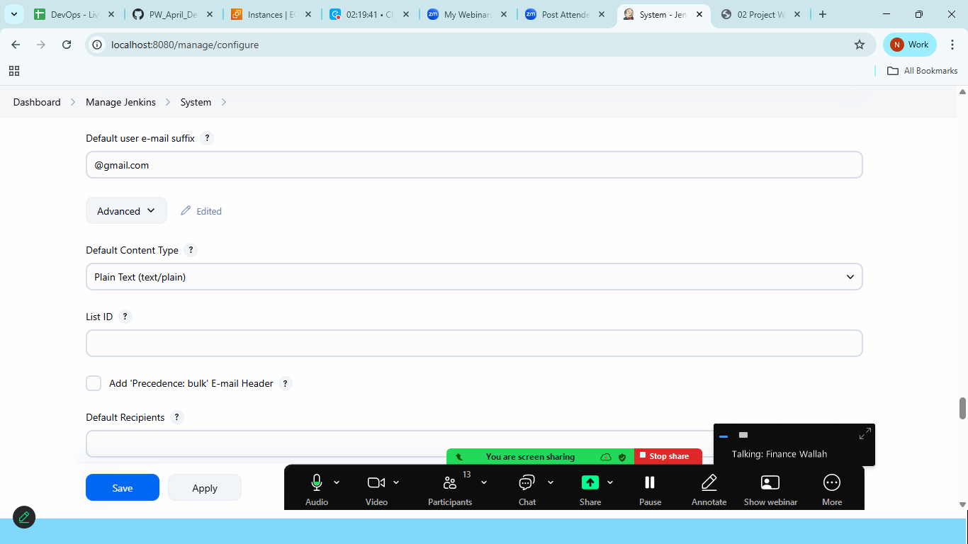
Click on Save and Apply
And build the Email Pipeline Project
(pipeline is already available in the text file 03 Email pipeline.txt file)
